# Constructing an Antenna Half

For making new antenna halves, use an existing example as reference. Some of the parts will also need to be scavenged from the broken element being replaced. *Figure 1* below shows the dimensions for the antenna element itself.

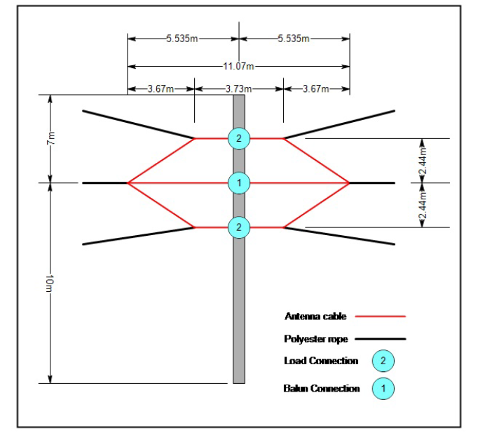

Figure . Antenna element measurements.

It is recommended that at least four already made antenna halves be kept in the radar hut. That way, spares can be made during takeover and simply replaced if any elements brake throughout the year.